Breakfast Items (available all day)

3 item breakfast (any 3 standard or luxury items) £3.10

Standard Items (add on for 50p each)
Egg, potato scone, hash brown, beans, mushrooms, tomato

Luxury Items (add on for 75p each\)
Sausage, bacon, Stornoway black pudding

The works & any drink £6.20
Egg, sausage, bacon, potato scone, Stornoway black pudding, hash brown, beans, mushrooms

Beans on toast £1.50
Toast with butter £1.10
Scrambled eggs on toast £2.10
Poached eggs on toast £2.80
French toast £2.50

Hot filled rolls

Bacon £2.10
Fried or scrambled egg £2.10
Sausage £2.10
Stornoway black pudding £2.10
Double £2.40
Triple £3.10

Off Peak Deal 1 – Hot drink and single hot roll £3.00
Off Peak Deal 2 – Hot drink and cake £3.00

PLEASE SEE BOARD BEHIND THE COUNTER OR ASK A MEMBER OF STAFF FOR OUR DAILY SPECIALS
From The Deli

All served with salad, crisps and your choice of filling

Fillings*:
ham, spicy chicken, cheese & coleslaw, ham cheese & chutney, chicken mayo, chicken & bacon mayo, egg mayo, tuna mayo, cajun chicken, coronation chicken, cheese tomato & pesto, salad.
* Any of our fillings can be prepared without mayonnaise for a healthier option

Why not add a delicious bowl of soup for just £2 extra.

Homemade soup (no bread) £2.20
Homemade soup with bloomer bread £2.90
Sandwich (also available Gluten Free) £2.70
Wrap £2.70
Baguette £3.50
Toastie £3.20
Panini £3.70
Baked Potato £4.20
egg mayo, chilli, chicken curry, coleslaw, cheese, beans, tuna mayo, chicken mayo

Village Centre Favourites

French toast, bacon & maple syrup £4.50
Fish tea £4.95
Chips - £1.50
Homemade chunky chips, Skinny fries, Cajun Skinny Fries
Omelette – any filling £4.95
Served with chips and salad
Chilli £4.50
Served with rice or chips
Club sandwich – Turkey & Ham £5.00
Served with chips and salad
Chicken, Ham or Turkey Salad £4.75
Chicken Curry £4.75
Served with rice or chips
Chips and a topping £2.50
Cheese, Gravy, or Curry Sauce
Why not add a buttered roll for just 30p

Drinks

Myrtle Espresso Coffee
(all coffee available as decaffeinated)

Espresso £1.80
Americano £2.00
Latte £2.10
Cappuccino £2.10
Mocha £2.30
(add a syrup flavour for 50p extra)

Hot Drinks

Pot of tea (free refills) £1.80
Herbal or fruit tea £1.90
Hot Chocolate Mountain £2.70
Babyccino £1.00
Cold Drinks

Soft drink (can 330 ml) £1.10
Fresh orange or apple juice £1.20
Still / sparkling water (330 ml) £1.00
Diluting juice (free refills) £0.90
Fruit shoot £0.65

Something Sweet

Thorntonhall Farm Ice Cream – various flavours

100ml tub £2.00

Have a look at our display cabinet for a choice of delicious cakes and
sweet snacks

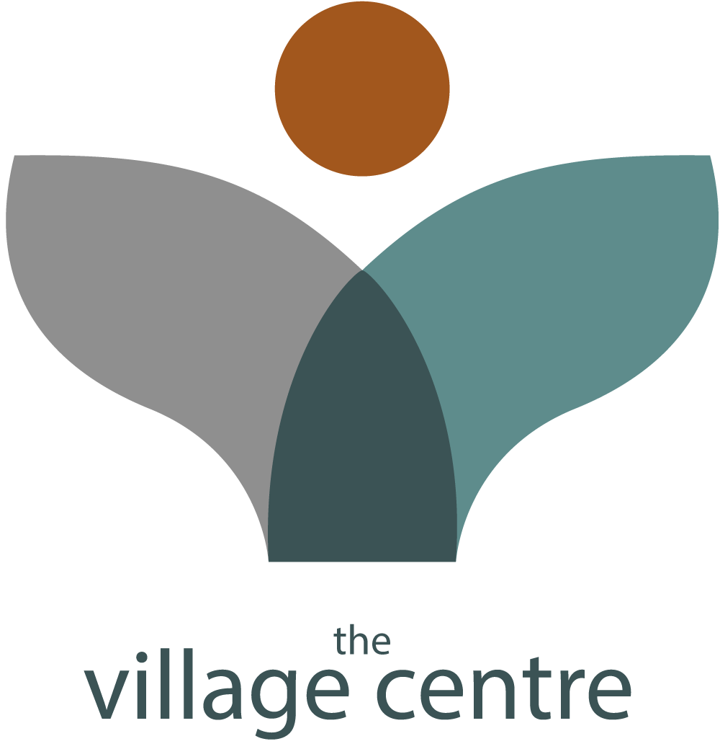
Café Menu
Opening hours
Monday – Saturday
9 am – 3 pm

01355 249062
www.thevillagecentre.co.uk
thevillagecentre
@village_centre

Charity Number: SC037829

